**Wood**

* Wood is hard fibrous material making the trunk and branches of trees or bushes
* Organic and hygroscopic material (it naturally absorbs and releases water)
* Renewable and sustainable resource
* Recyclable and biodegradable
* Types of trees
  + Conifer trees
    - Needle-like leaves, cones
    - Remain evergreen
    - Examples:
      * Pine
      * Fir
      * Spruce
      * Larch tree
  + Decidous trees
    - Loose leaves in fall to survive winter better
    - Example:
      * Oak
      * Beech
      * Birch
      * Linden
* Parts of tree:
  + A tree is a perennial plant with roots, a trunk, side branches and twigs
  + A branch system forms a crown
  + The trunk carries water with dissolved minerals upwards and downwards
  + The leaves turn sunlight into their energy (glucose), they also make the oxygen in the air

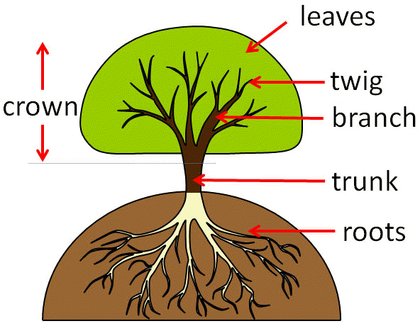

* Wood components
  + Chemically, wood consists of 3 polymers:
    - Cellulose – an orgainc compound derived from glucose, gives the wood its strenght
    - Hemicellulose – gives wood its flexibility
    - Lignin – the glue which holds fibres together, gives wood its stiffness
    - Water
* Wood characteristics
  + Physical properties
    - Low weight
    - Typical smell and colour
    - Perfect insulator
    - Poor electrical and heat conductivity
  + Mechanical properties
    - Strong
    - Durable
    - Hardness
    - Tension
    - Density
  + Chemical properties
    - Flammability
    - Reactivity with oxygen, water and acid
* Hardwood
  + Comes from flowering plants (oak, beech, maple)
  + Last longer, they are denser
  + More expensive
  + Used for high quality furniture, musical instruments, floors, counstruction and boatbuilding
* Softwood
  + Come from evergreen conifers (pine, spruce)
  + Grow rapidly, less stable
  + Cheaper, easier to work with
  + Used for manufacturing of windows, interior mouldings amd MDF (medium density fiberboard)
* Wood products
  + Primary
    - Logs are used as raw materials
    - 4 cathegories
      * Lumber
        + Dimenstional lumber
        + Laminated lumber
        + Decking
        + Timber
      * Pulp
      * Panel products
        + Veneered products – Plywood
        + Non-veneered products – Fiberboard, particleboard
      * Paper
  + Secondary
    - Manufactured wood products
      * Furniture
      * Pallets
      * Moldings
      * Others
* Wood residues
  + Wood pellets – Wood Briquettes
    - From wood sawdust
    - Firstly moisture is removed and then compressed with heat (lignin is a glue)
    - Perfect biofuel
  + Manufactured Boards
    - OSB (Oriented strand board)
      * Layers of large chips of wood are glued together and pressed
    - MDF (Medium density fiberboard)
    - Particle board
    - Plywood
      * 3 – 7 plies glued together